**INITIAL FEASIBILITY STUDY ON KABOGOBOGO RIVER AND CYAMWAKIZI POND DEGRADATION**

**2. Itariki y’ubugenzuzi:** 03/10/2023.

**3. Inyigo yibanze:** Gusura icyuzi cyamwakizi numugezi wa Kabogobogo mu rwego rwo kubungabunga ibidukikije ku mugezi wa Kabogobogo n’Icyuzi cya Cyamwakizi bikozwe na karere ka Gisagara kubufatanye na n’Umuryango utari uwa Leta (Great Lakes Inititave for Relief and Development/ GLIRD).

.**4. Lisiti yabagiye gukora ubugenzuzi**

|  |  |  |  |
| --- | --- | --- | --- |
| **N0** | **AMAZINA** | **ICYO ASHINZWE** | **TELEFONI** |
| 1 | NDEKEZI Olivier | Agronomist/ Umurenge wa Kansi | 0784182108 |
| 2 | SHYAKA Olivier | Land Manager/ Umurenge wa Kansi | 0783577826 |
| 3 | KAGAME Samuel | EIA Expert/ GIS Specialist | 0786974902 |
| 4 | RUKUNDABATWARE Anastase | Umunyamuryango wa GLIRD | 0788489984 |

**5. Uko igikorwa cya genze:**

Akarere ka Gisagara, hamwe na GLIRD twasuye umugezi wa Kabogobogo n’Icyuzi Cyamwakizi hagamijwe kumenya impamvu nyakuri zateye iyangirika rikomeye ryabyo no gushakirahamwe igisubizo.

**5.1. Umugezi wa Kabogobogo**

Umugezi wa Kabogobogo unyura mu mirenge ibiri (2) y’Akarere ka Gisagara ariyo Kansi, na Mugombwa. Iyangirika rikomeye ry’uyu mugezi riterwa ahanini ni igihurira (siltation) riva ku cyogogo cyambaye ubusa bikamanuka bijya muri uyu mugezi ; ubuhaname buri hejuru kandi butariho amaterasi yikora buhoro buhoro (progressive terracing); bamwe mu baturage binura umucanga bakangiza inkombe z’umugezi no kuba babikora binyuranyije n’amabwiriza y’Ikigo gishinzwe guteza imbere mine, peteroli na gaz mu Rwanda (RMB) ndetse n’Itegeko N0 48/2018 ryo kuwa 13/08/2018 rigenga ibidukikije (Environmental Law).

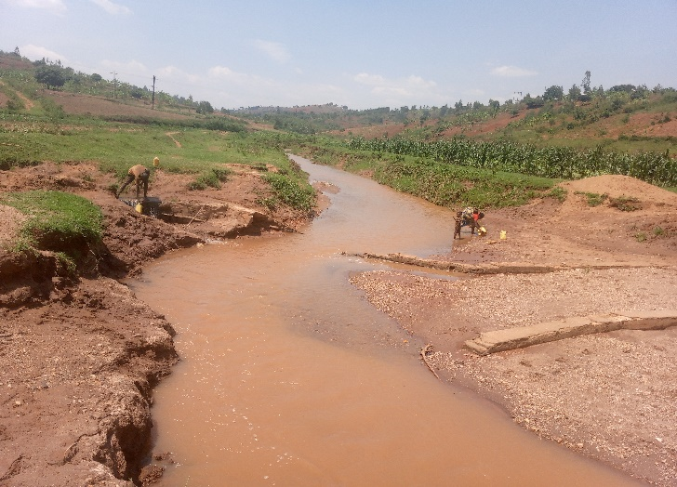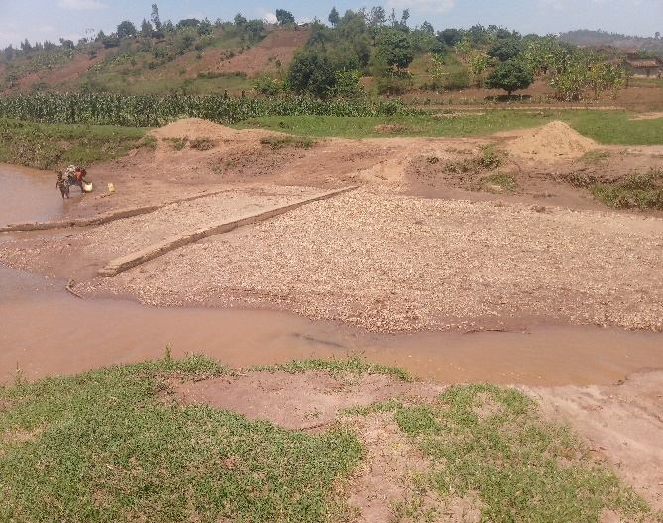

*Aya mafoto yombi aragaragaza uburyo abaturage binuramo umucanga binyuranyije n’amategeko.*

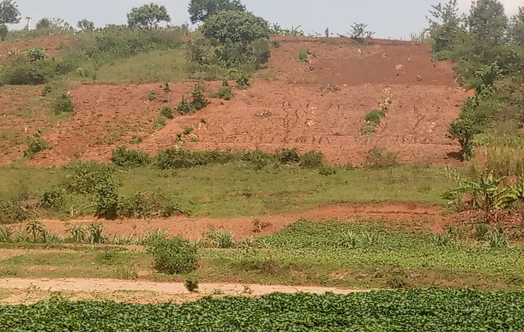

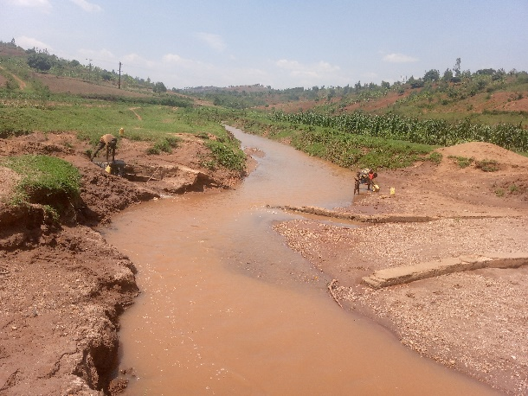  
*Iyi foto y’ibumoso iragaragaza uburyo isuri Iyi foto y’iburyo iragaragaza uburyo*

*iva mu butaka bwambaye ubusa ikiroha mu ibikorwa by’ubuhinzi bikorwa bitubahirije*

*mugezi. intera ya metero 10 nk’uko biteganywa*

*n’Itegeko ryo kurengera ibidukikije.*

**5.2. Icyuzi cya Cyamwakizi**

Icyuzi cya Cyamwakizi gikora ku Mirenge itatu (3) y’Akarere ka Gisagara ariyo Kigembe, Kansi na Mugombwa, kikinjirwamo n’imigezi ibiri (2) ariyo Kabogobogo n’undi uturuka mu gishanga cya Kigaga.

Mu gihe twasuraga iki cyuzi, twakoze isesengura (assessment) dufatanyije n’abaturage twahasanze hamwe n’abayobozi bo mu nzego z’ibanze. Muri iki kiganiro, aba bose bahamije ko iyakingirika ryacyo ryihuta cyane. Nyuma yo gusura iki cyuzi, hakozwe isesengera hakoreshejwe ikoranabuhanga (spatial analysis) rigaragaza ko:

* Ifoto igaragaza iyangirika ryicyuzi cya Cyamwakizi

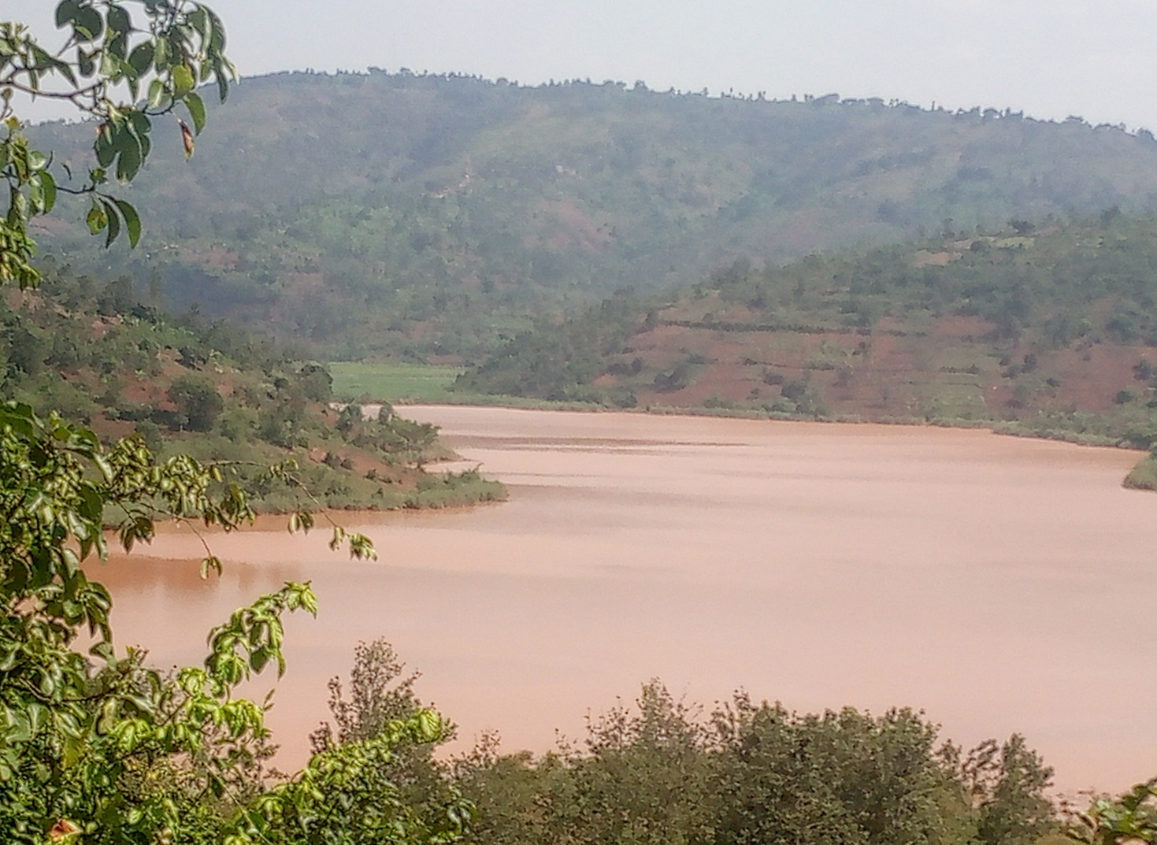

* Ishusho ya satellite yo mu mwaka wa 2013 igaragaza ko icyuzi cya Cyamwakizi cyari gifite ubuso bungana na Ha 40.5 nk’uko bigaragara ku ifoto ikurikira:

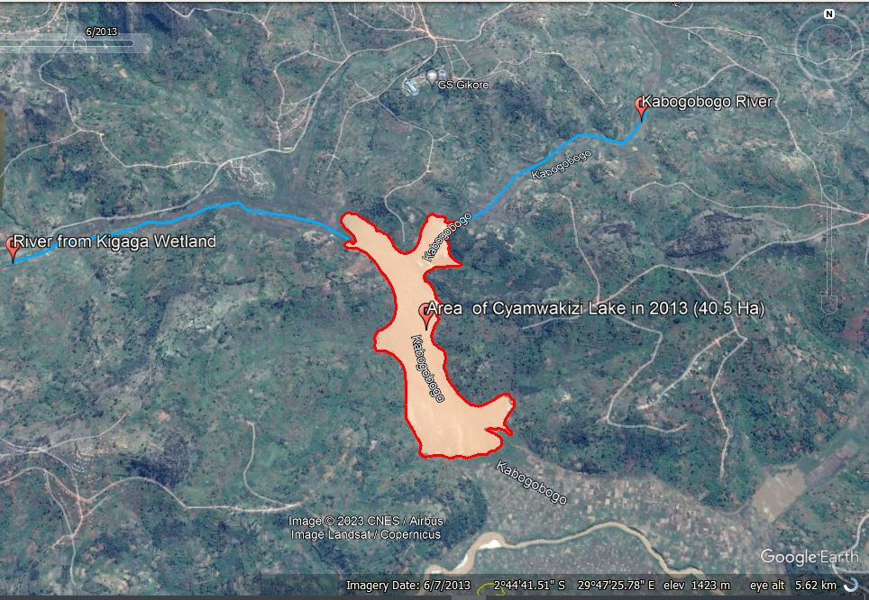

* Ishusho ya satellite yo mu mwaka wa 2023 igaragaza ko nyuma yo kwangirika, icyuzi cya Cyamwakizi kiri ku buso bungana na Ha 30.2 nk’uko bigaragara ku ifoto ikurikira:

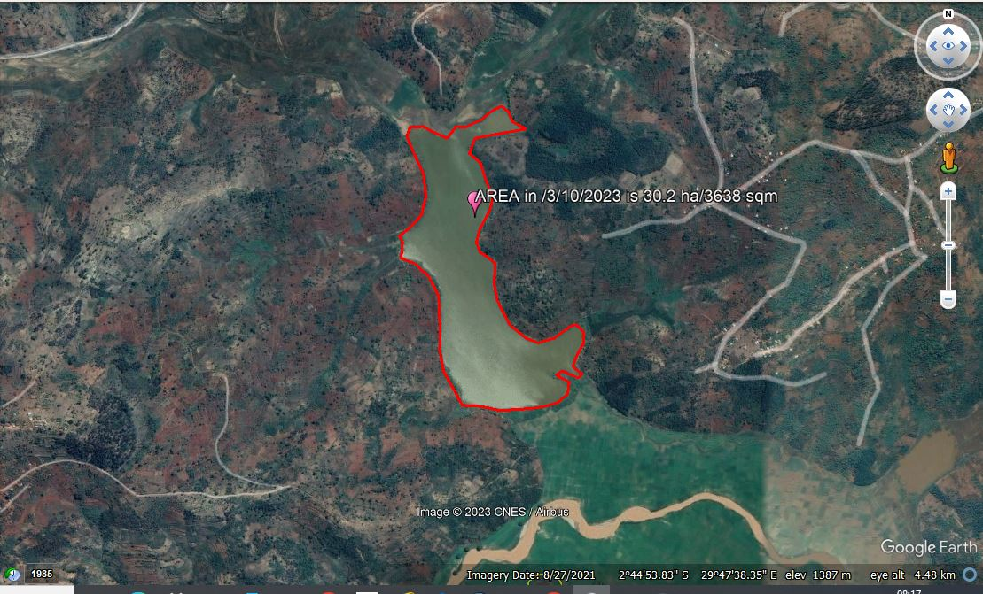

Aya mashusho uko ari abiri ya satellite aragaragaza ko kuva mu mwaka wa 2013 kugeza ku mwaka wa 2023 icyuzi cya Cyamwakizi cyagabanutseho ubuso bungana na Ha 10.3 (Ha 40.5 – Ha 30.2).